Ideation Phase
Empathize & Discover

Date | 3 July 2026
Team ID
Project Name | RK-HEALTH
Maximum Marks | 4 Marks

Empathy Map Canvas:
An empathy map is a simple, easy-to-digest visual that captures knowledge about a user’s behaviours and attitudes.

It is a useful tool to helps teams better understand their users.
Creating an effective solution requires understanding the true problem and the person who is experiencing it. The exercise of creating the map helps participants consider things from the user’s perspective along with his or her goals and challenges.
Example:


Reference: https://www.mural.co/templates/empathy-map-canvas

RK-HEALTH Project Empathy Map (User Persona: Rahul, 35, Type-2 Diabetes patient)
SAYS (User Sayings):  • "I need a simple app to track all my doctor visits and medications."  • "I keep forgetting my daily insulin schedule."  • "I want to access my health reports on my phone instantly." | THINKS (User Thoughts):  • "I hope I don't miss my clinic checkup next week."  • "Google searches make me anxious about my symptoms."  • "I wish my care provider could see my compliance log."
DOES (User Actions):  • Sets multiple phone alarms for daily pill reminders.  • Keeps paper doctor prescription slips in folder cabinets.  • Calls clinic desk manually to schedule or change slots. | FEELS (User Emotions):  • Overwhelmed managing multiple medication cycles.  • Frustrated using disjointed notes and tracking tools.  • Hopeful that an integrated portal can simplify his care.
PAINS (User Pain Points):  • Lack of a single app containing lists, calendars, and logs.  • Specialist routing is confusing and hard to choose.  • Poor medication compliance due to manual logs. | GAINS (User Benefits & Goals):  • Peace of mind through Google Calendar integration and alerts.  • Specialized symptom triage and guidance from AI chat.  • Printable report summaries to share with doctors.

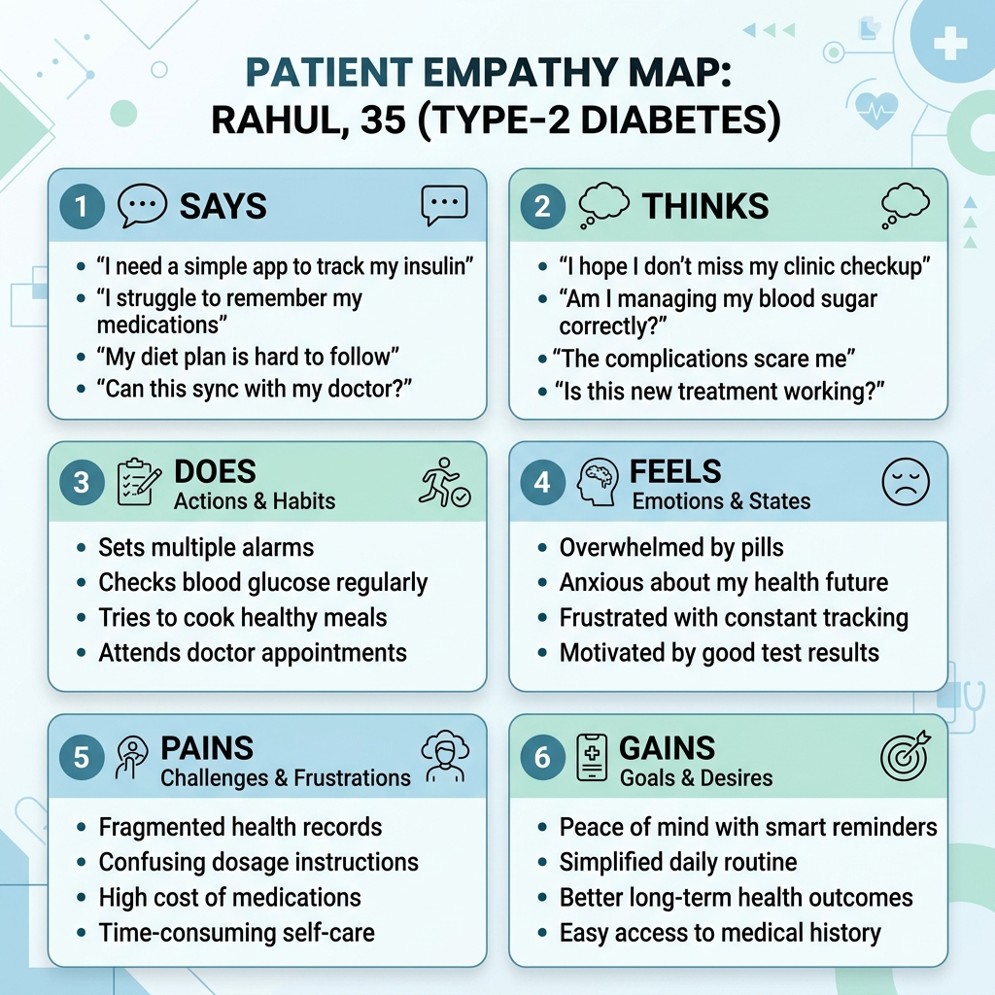
Figure 1: Empathy Map Canvas for Patient Persona (Rahul, Type-2 Diabetes)

